Experiment 5: Develop a SIMATS Library Book Reservation Application as SaaS
Aim
To develop a cloud-based Library Book Reservation System for SIMATS using Zoho Creator.
Software Used
- Zoho Creator
- Deluge Workflow
- Web Browser
Algorithm
- Create Student Registration form.
- Create Book Details form.
- Create Book Reservation form.
- Create Book Issue form.
- Create Book Return form.
- Verify book availability.
- Reserve and issue books.
- Generate reservation reports.
Output:
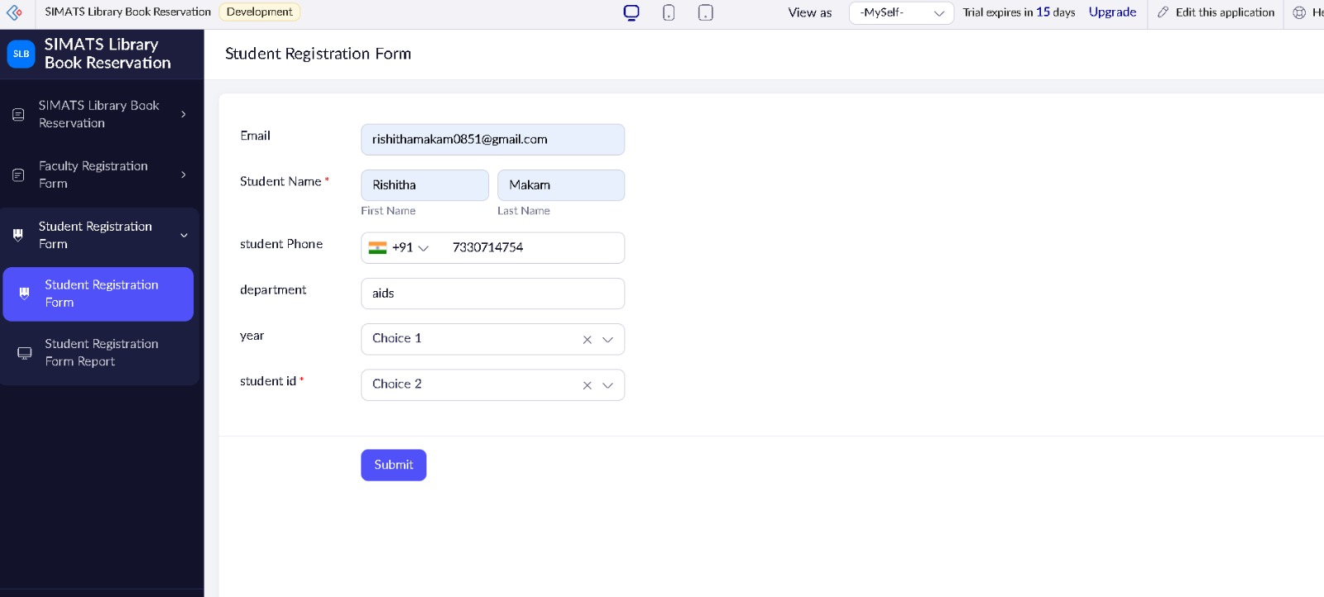

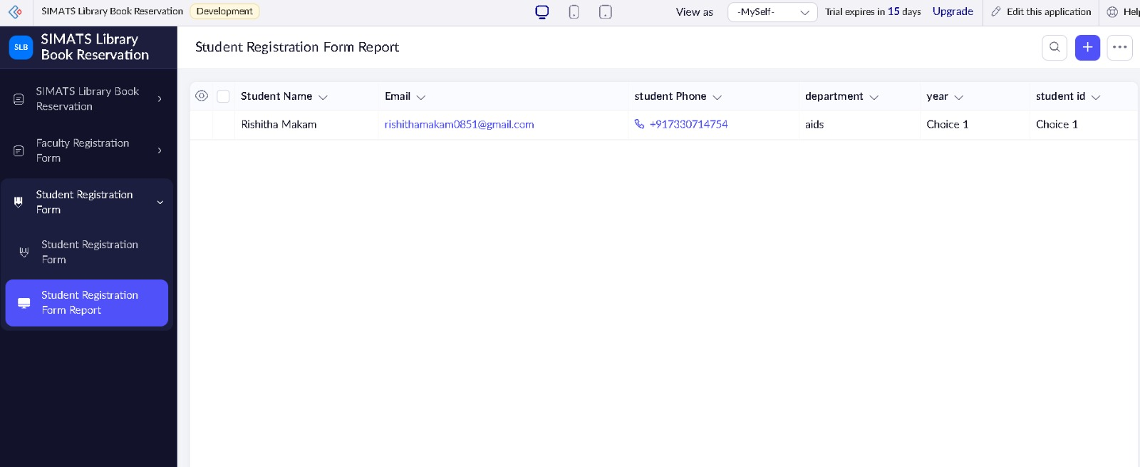
Result:
A SaaS-based Library Book Reservation System was successfully developed for managing library resources and student reservations.

